PRESS RELEASE

COMMUNICATIONS AND MEDIA TEAM OF THE ASEAN SUMMIT 2023

No.09/SP/TKM-ASEAN2023/ENG/8/2023

ASEAN Socio-Cultural Community Council Reaffirms Commitment to Realize ASEAN as Epicentrum of Growth

Jakarta, 30 Agustus 2023 – The 30th ASEAN Socio-Cultural Community (ASCC) Council Meeting, held in Jakarta on August 29, 2023, has endorsed five documents that will be further discussed and adopted at the 43rd ASEAN Summit, scheduled for September 5-7, 2023, in Jakarta, Indonesia.

The Meeting was chaired by the Coordinating Minister for Human Development and Cultural Affairs of the Republic of Indonesia, Prof. Dr. Muhadjir Effendy as the Chairman for the 30th ASCC, and attended by ASCC Ministers of ASEAN member countries, Timor-Leste as observer, and the Secretary General of ASEAN.

"We have made great progress in advancing an inclusive, sustainable, and people-centred ASEAN. Reflected through initiatives held this year and the outcome documents submitted for adoption or notation to the 43rd ASEAN Summit," said the Coordinating Minister for Human Development and Cultural Affairs Prof. Dr. Muhadjir Effendy.

The five outcome documents will be adopted by the ASEAN Leaders at the 43rd ASEAN Summit are related to disability-inclusive region, climate change, gender equality and family development, early childhood care and education, and sustainable resilience.

In addition, 21 documents on various socio-cultural issues will be notated at the 43rd ASEAN Summit for notation. These documents contributed to the theme of this year Indonesia’s ASEAN Chairmanship “ASEAN Matters: Epicentrum of Growth”. The Meeting also reaffirms its priority to discuss the ASEAN Vision 2045 and its attendant document at the earliest.

Lao PDR will carry over the ASCC Chairpersonship for 2024. and ASEAN Chairmanship 2024. The 31st ASCC Meeting will be held on March 25-26, 2024, in Luang Prabang, Lao PDR.

***

For further information, please contact the following:

Director of Information and Media of the Ministry of Foreign Affairs - Hartyo Harkomoyo (+62811831899).

Get more information at http://asean2023.id, https://infopublik.id/kategori/asean-2023, dan https://indonesia.go.id/kategori/ragam-asean-2023

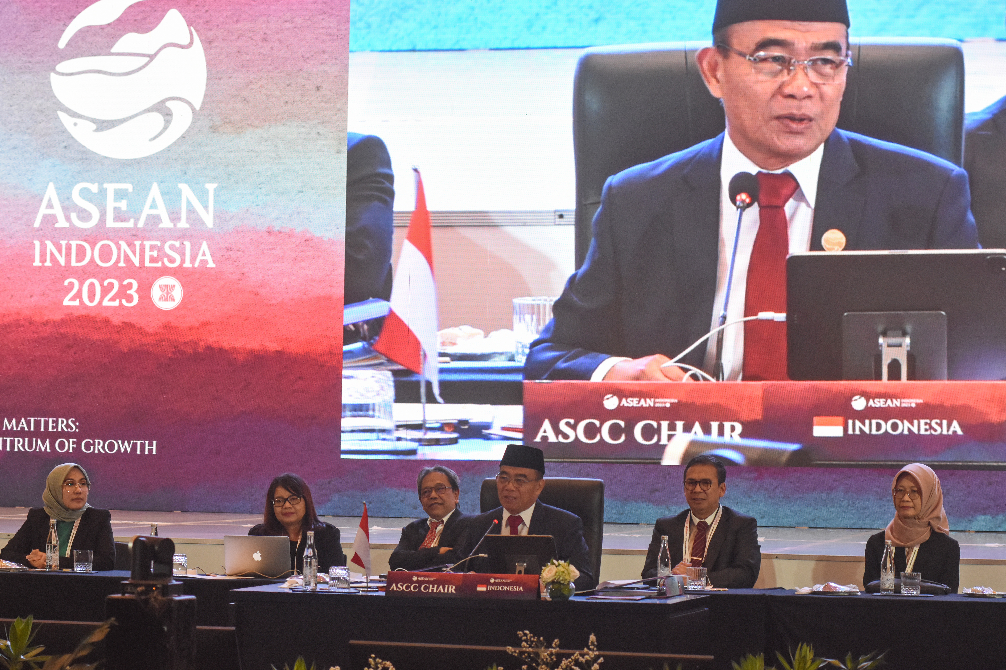

Coordinating Minister for Human Development and Cultural Affairs of the Republic of Indonesia, Prof. Dr. Muhadjir Effendy (third from the right) chaired the 30th ASEAN Socio-Cultural Community (ASCC) Council Meeting, held in Jakarta, Tuesday (29/8/2023). The Meeting discussed various socio-cultural issues in ASEAN leading up to the ASEAN Summit that will be held 5-7 September 2023. ANTARA FOTO/Indrianto Eko Suwarso/rwa

